# School-Based Incident Tabletop Exercise

Date: August 22, 2024, from 1:00-3:00 pm

# Exercise Agenda:

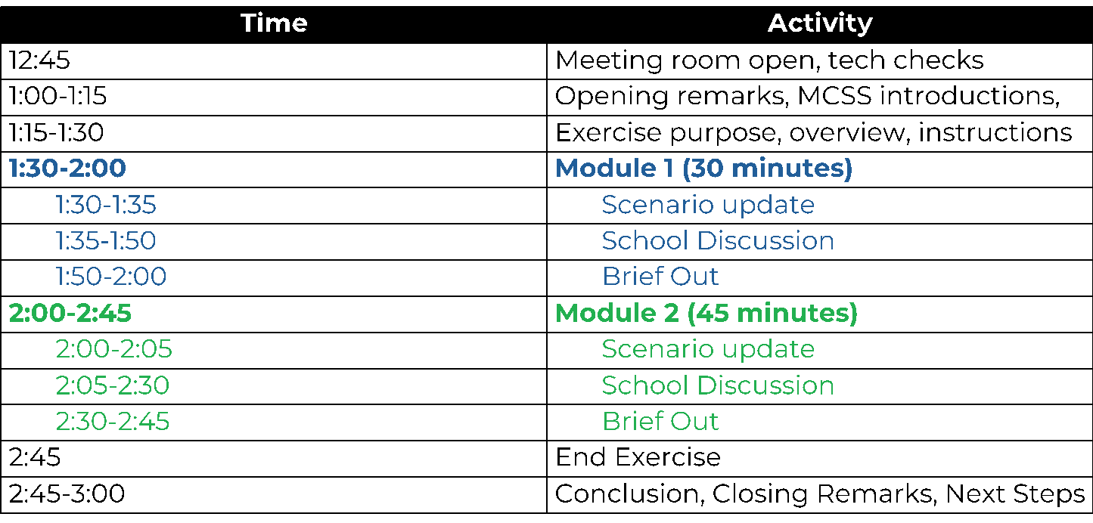

# Exercise Objectives

* Help non-public schools to evaluate the effectiveness in responding to and recovering from a significant incident.
* Internally identify capabilities and gaps to improve plans.
* Understand resource and assistance needs in non-public schools, and the ability of the state and other stakeholders to provide support.

# Exercise Ground Rules

* Short discussion after both modules among local groups.
* No “right” answers - discuss all options.
* Test the plan(s).
* Accept the artificialities of the scenario.
* Make notes on your responses and be prepared to brief out to the larger group.
* This is a self-evaluation opportunity for the school.

# Module 1 Facilitator’s Questions

* What preparations does your school make prior to the expected severe weather?
* How does your school receive information about weather-related threats?
  + Who is responsible for monitoring these alerts?
* What systems are available that can facilitate information sharing and coordination among your school and relevant stakeholders?
* What guidance does your school expect from local or state authorities?

# Optional Module 1 Questions

* How does the incoming storm change your school’s operations?
  + - Is there sufficient information to warrant a change in the current normal operating status?
    - Would any emergency operations or other plans be initiated or reviewed at this time?
    - Who would make this decision, and how would it be communicated?
    - Are there external stakeholders who should be notified if you have enacted a change in your school’s operating status?
    - Are parents notified?
      * + If so, how are they notified?
* Are there any messages or communications from your city, county, neighboring counties, or state that your school would be monitoring?
* Would your school choose to communicate with staff about this impending storm?
  + - Does your plan outline communication procedures?
    - With whom would you communicate at this time (e.g., senior staff only, supervisors, all staff, others)?
    - How would communications be disseminated? Are there any technology redundancies?
    - Does your school have pre-determined messaging for this kind of event?

# Module 2 Facilitator’s Questions

* What actions would this updated information prompt, if any?
* What information are you sharing within the school?
  + To whom will this information be disseminated, and how will it be delivered?
  + How are you coordinating with transportation providers outside of your county?
* Who are you contacting outside of the school (first responders, parents, state resources, organization/enterprise POCs)?
* Would your school activate an emergency plan at this time?
  + What would trigger activation?

# Optional Module 2 Questions:

* Would school administration consider releasing students and teachers early or in a different manner?
  + How much time ahead of an event like this would be required for adequate dismissal?
  + What is the best way for school leadership to communicate an early dismissal to staff? What are the current protocols, expectations, and mechanisms for this instance?
  + How would your school handle individual requests for early release?
    - How are these early releases approved, communicated up the chain, or tracked?
* What information from the city, county, or state might automatically trigger your school to activate your emergency operations plan?
* What factors would impact your decision to close school?