School-Based Incident Tabletop Exercise
Date: August 22, 2024, from 1:00-3:00 pm

Exercise Agenda:
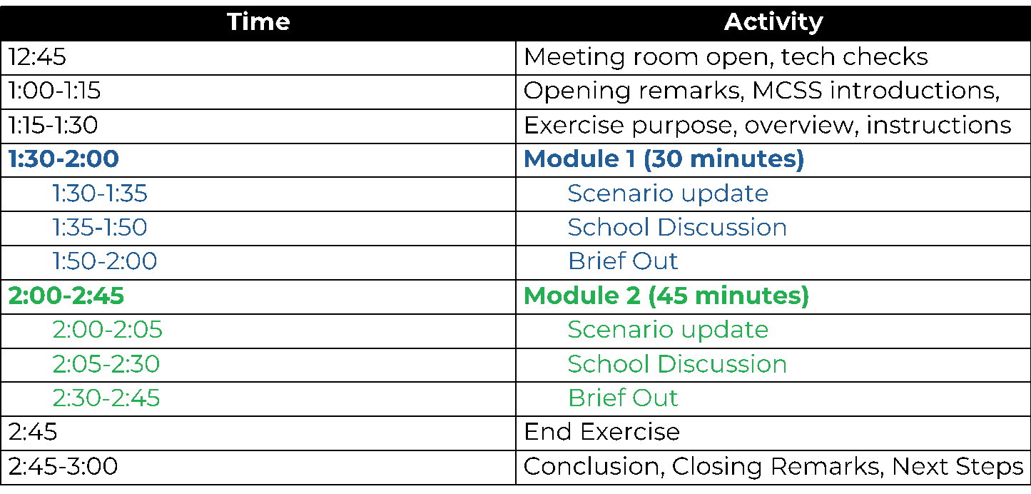

Exercise Objectives
- Help non-public schools to evaluate the effectiveness in responding to and recovering from a significant incident.
- Internally identify capabilities and gaps to improve plans.
- Understand resource and assistance needs in non-public schools, and the ability of the state and other stakeholders to provide support.

Exercise Ground Rules
- Short discussion after both modules among local groups.
- No “right” answers - discuss all options.
- Test the plan(s).
- Accept the artificialities of the scenario.
- Make notes on your responses and be prepared to brief out to the larger group.

- This is a self-evaluation opportunity for the school.

Module 1 Facilitator’s Questions
- What preparations does your school make prior to the expected severe weather?
- How does your school receive information about weather-related threats?
  - Who is responsible for monitoring these alerts?
- What systems are available that can facilitate information sharing and coordination among your school and relevant stakeholders?
- What guidance does your school expect from local or state authorities?

Optional Module 1 Questions
- How does the incoming storm change your school’s operations?
    - Is there sufficient information to warrant a change in the current normal operating status?
    - Would any emergency operations or other plans be initiated or reviewed at this time?
    - Who would make this decision, and how would it be communicated?
    - Are there external stakeholders who should be notified if you have enacted a change in your school’s operating status?
    - Are parents notified?
        - If so, how are they notified?
- Are there any messages or communications from your city, county, neighboring counties, or state that your school would be monitoring?
- Would your school choose to communicate with staff about this impending storm?
    - Does your plan outline communication procedures?
    - With whom would you communicate at this time (e.g., senior staff only, supervisors, all staff, others)?
    - How would communications be disseminated? Are there any technology redundancies?
    - Does your school have pre-determined messaging for this kind of event?

Module 2 Facilitator’s Questions
- What actions would this updated information prompt, if any?
- What information are you sharing within the school?
  - To whom will this information be disseminated, and how will it be delivered?
  - How are you coordinating with transportation providers outside of your county?
- Who are you contacting outside of the school (first responders, parents, state resources, organization/enterprise POCs)?
- Would your school activate an emergency plan at this time?
  - What would trigger activation?

Optional Module 2 Questions:
- Would school administration consider releasing students and teachers early or in a different manner?
  - How much time ahead of an event like this would be required for adequate dismissal?
  - What is the best way for school leadership to communicate an early dismissal to staff? What are the current protocols, expectations, and mechanisms for this instance?
  - How would your school handle individual requests for early release?
    - How are these early releases approved, communicated up the chain, or tracked?
- What information from the city, county, or state might automatically trigger your school to activate your emergency operations plan?
- What factors would impact your decision to close school?

